Sibford Ferris Footpaths Nos. 4 & 5 (347/4/10 & 347/5/10) Anomaly Report

The County Council is undertaking a review of its Definitive Map and Statement, which is the legal record of public rights of way. Part of this review includes identifying paths that have noticeably been marked incorrectly – or incompletely – on the Map.

Over time, the Map has been routinely updated since it was first produced in the 1950s, as revisions to Ordnance Survey mapping were produced. Our path data must be overlaid on to that Ordnance Survey mapping which can, sometimes, result in minor alignment anomalies creeping in that require rectification. Where these anomalies come to light, the Map can only be amended by the Council making an Order that modifies the Map. One such path issue has come to light as detailed below.

The present Definitive Map, dating from 2006, records the paths as shown below.

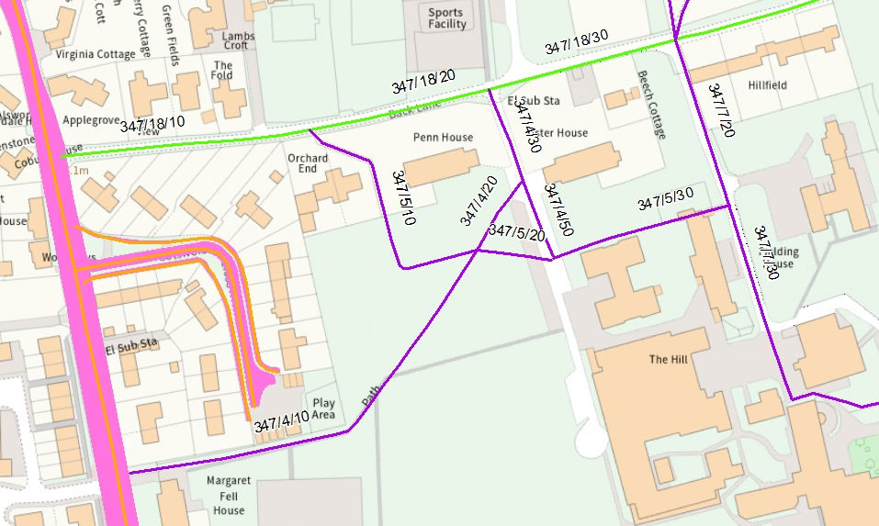
F
E
B
C
D
A
© Crown copyright and database rights 2026 OS AC0000851087

This shows Footpath No. 4 running to the south of Cotswold Close (from point A) and turning to run north-east to the track beside Lister House at point B. It then runs south to join Footpath No. 5 at point D and a further section of the same path also runs north from point B to join Bridleway No. 18. Footpath No. 4 is signed from the road at point A.

Footpath No. 5 runs from point C at Back Lane (also Bridleway No. 18) on an enclosed footway between Penn House and Orchard End, then continues across a school sports ground and through the school site to join Footpath No. 7 at point E.

The survey of rights of way undertaken by the parish council in the 1950s, which forms the basis of the initial Definitive Map of Public Rights of Way, shows the routes of Footpaths Nos. 4 and 5 running diagonally and crossing fields before the land had been developed for housing. The paths were diverted by legal Order in 1959 and 1971 and the effect of these Orders was not then reproduced accurately onto the 1999 Definitive Map. This error was then simply repeated on the current, 2006 Definitive Map.

1950s Parish Survey Map and Form

The path’s original inclusion on the first Definitive Map produced in the 1950s was based on a submission by the Parish Council made in 1951. This is shown below.

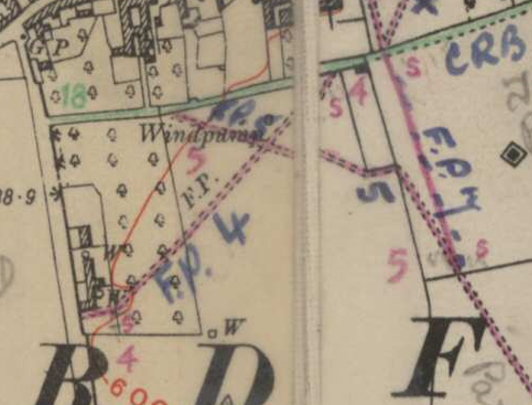

1953 Draft Definitive Map

This correctly records the routes as claimed by the parish council.

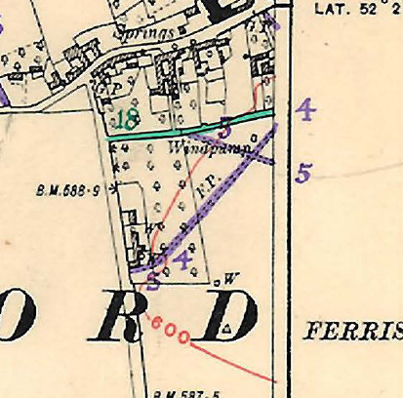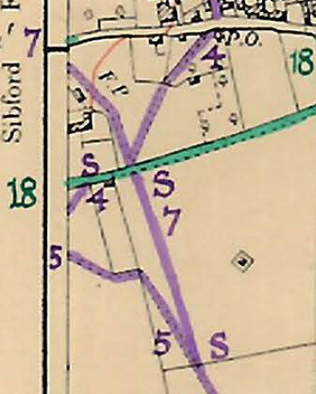

1953 Provisional Definitive Map

This also records the routes as claimed by the parish council.

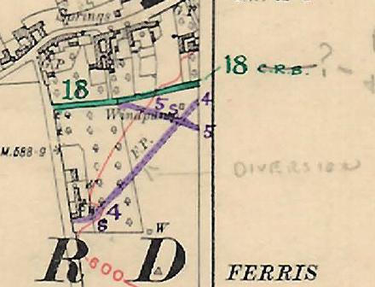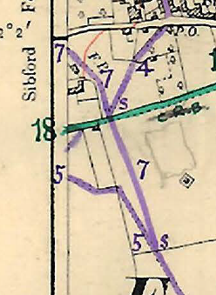

1953 Definitive Map and Statement

This records the routes as claimed by the parish council. The paths are shown slightly displaced to the east due to having been drawn onto a transparent overlay which was misaligned when the document was scanned.

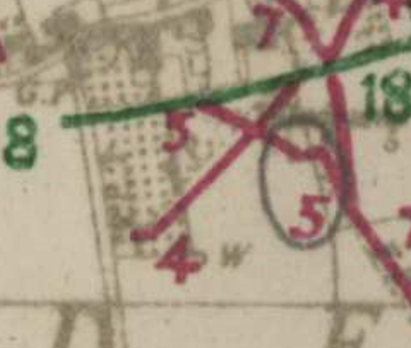

The first Definitive Statement, accompanying this Map describes the paths as follows:

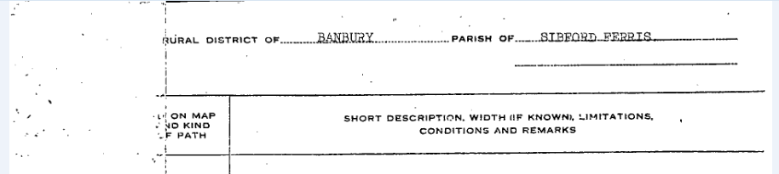



1959 Stopping-Up Order
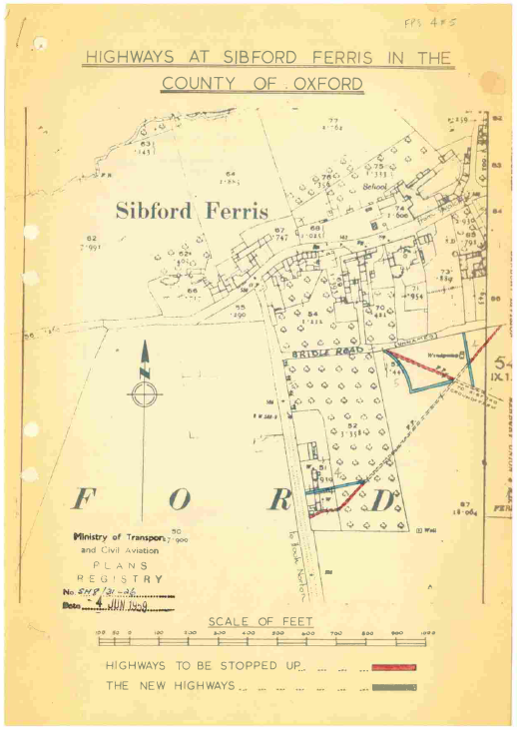

This Order was made so that development of the area could take place. The above Order plan has been overlaid onto current mapping, below.

The Order did not affect the section of path shown on the base mapping between what is now Cotswold Close and Penn House.

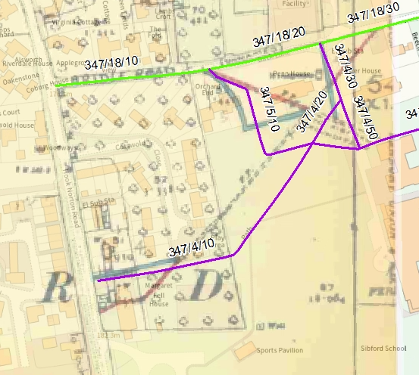

The overall intended effect of the Order can be discerned from the above mapping, but it can be seen that this has been overly (and incorrectly) exaggerated when transferred on to later Definitive Maps.

1968 Definitive Map and Statement

This is the first revision of the Definitive Map that took place subsequent to the 1959 Order and appears to show the effect of the Order, but it was drawn at a small scale and quality which makes it difficult to understand.

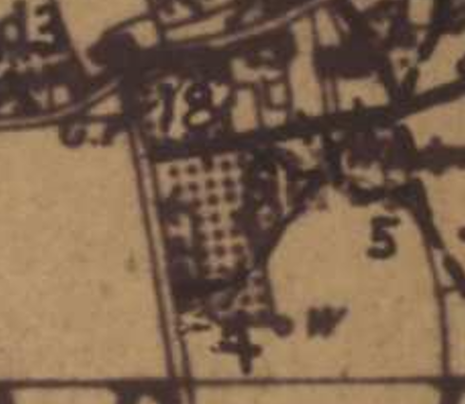

1971 Diversion Order
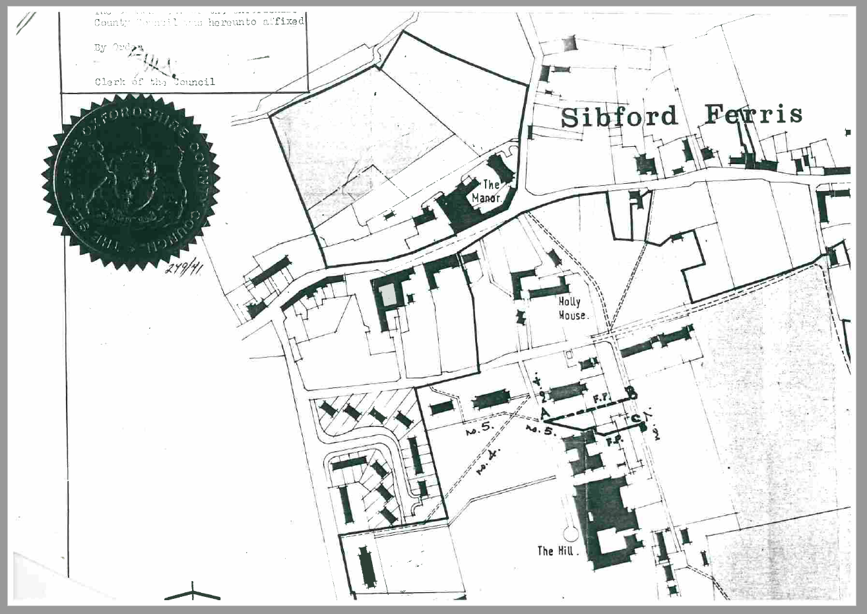

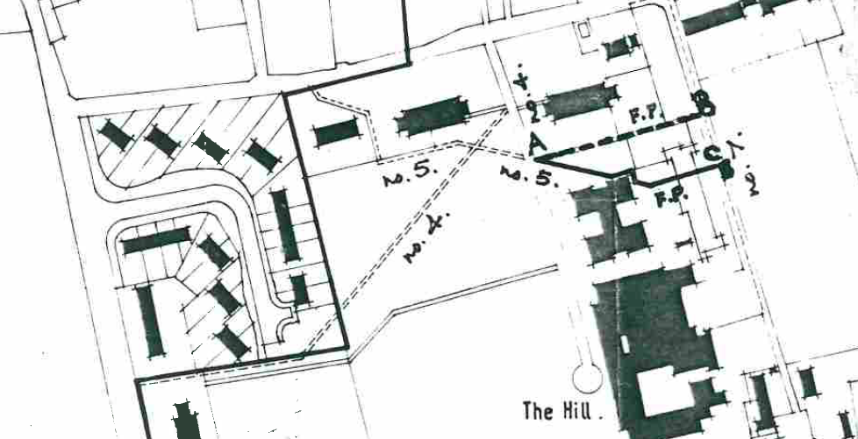

This Order diverted part of Footpath 5 for the benefit of the school where the path passes through the school site onto a line running to the north of the existing route. This Order plan also correctly interprets for the most part the effect of the earlier 1959 Order in respect of Footpath 4, but does not do so in respect of Footpath 5.

1999 Definitive Map and Statement

This map now clearly shows Footpaths 4 and 5 incorrectly, in that the effect of the 1959 Order is not properly reflected. Footpath 4 should turn to run north-east at the end of Cotswold Close and Footpath 5 should run against the boundary of the properties known as Penn House and Orchard End, rather than running into the school sports ground and turning east to run across it.

Furthermore, the effect of the 1971 Order is not shown correctly in that Footpath 5 is shown running immediately alongside a school building but should be shown running slightly to the north.
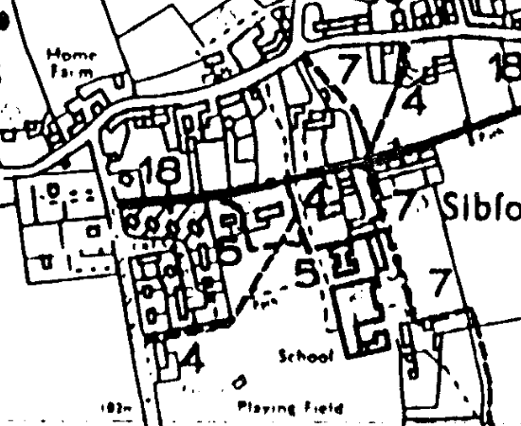

2006 Definitive Map and Statement

This, current, Map similarly shows the route of the path with the errors shown in the 1999 map repeated here.

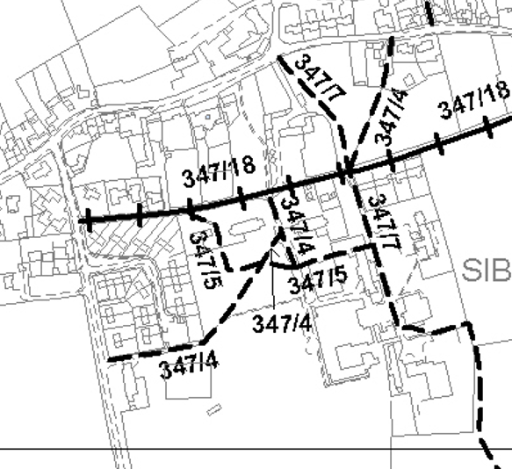

The current Definitive Statements describe the paths as follows and note the Orders of 1959 and 1971.

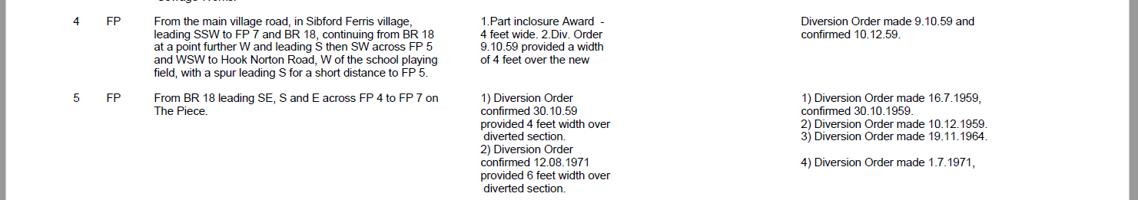

Images from Google Street View

Point A
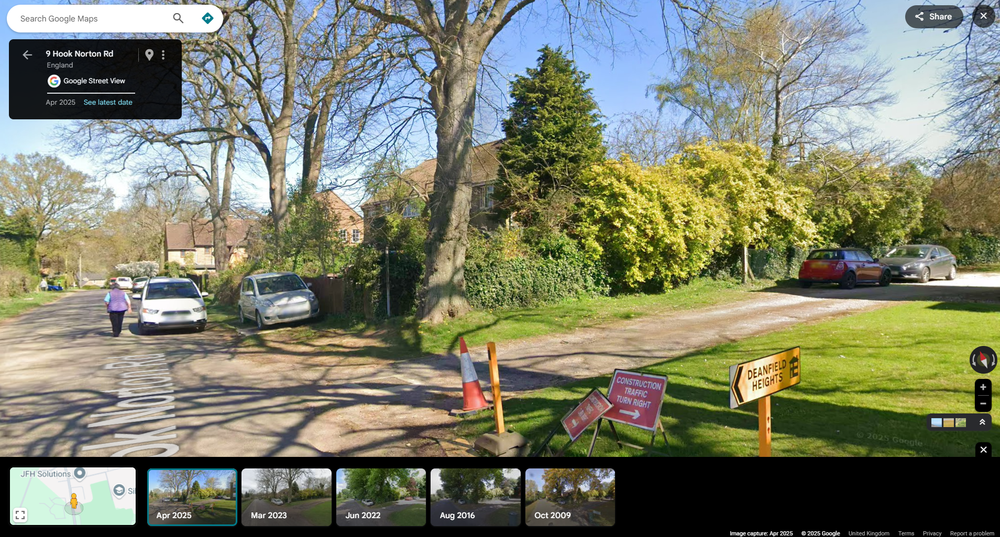

End of Cotswold Close in 2009, showing pedestrian gate on legal line of path as diverted in 1959 (point F)
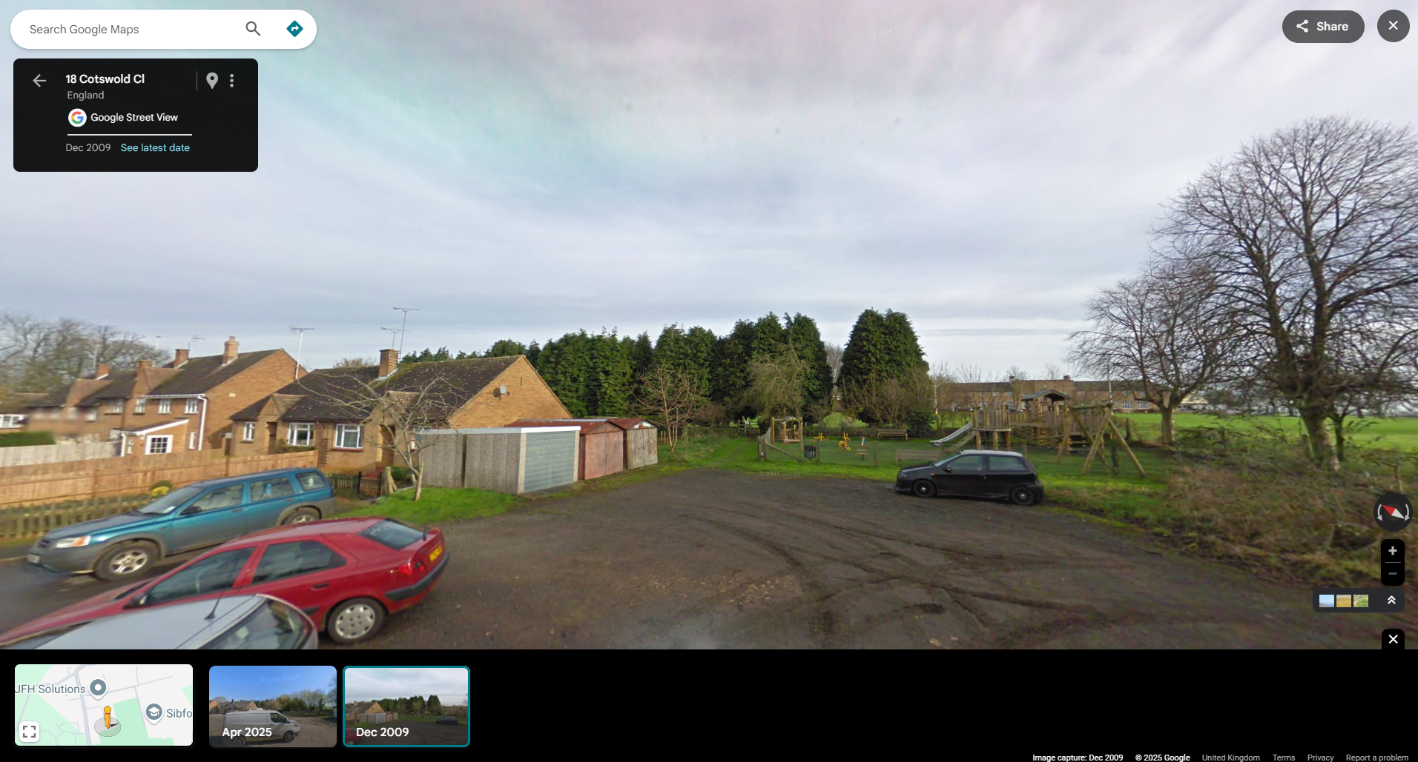
Pedestrian gate

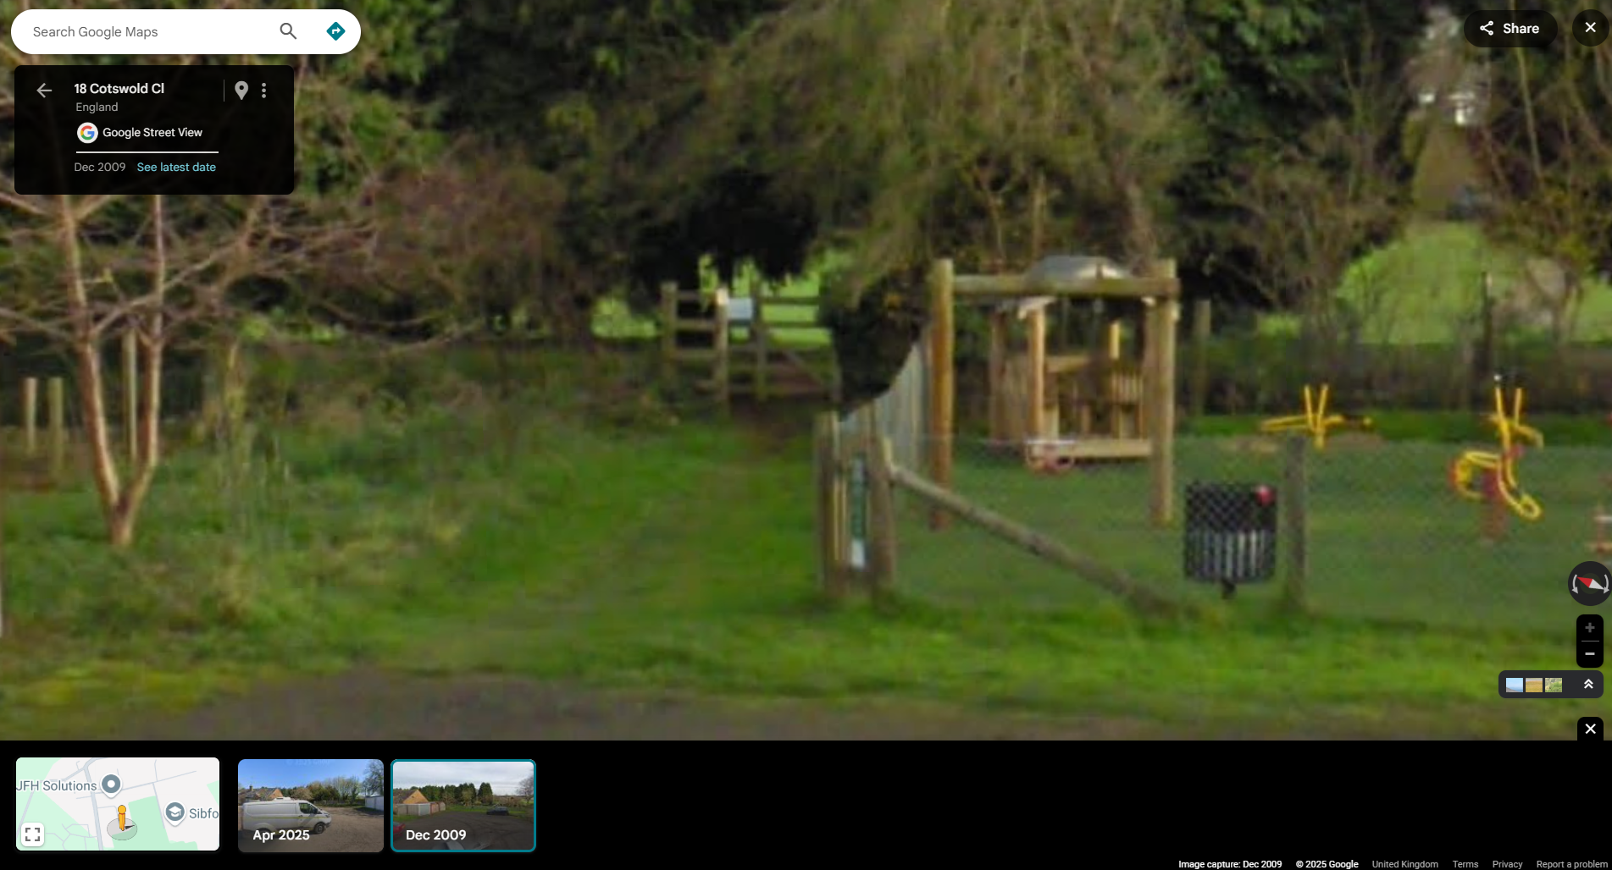

No further legal changes have been made and, therefore, the Definitive Map should accurately reflect the effects of the 1959 and 1971 Orders, whereas it seems to show – for the most part – the routes that are in use on the ground. These routes shown on the 1959 and 1971 Orders now run through the property known as Orchard End and also the children’s play area at the end of Cotswold Close. The above image taken from Google Street View dating from 2009 shows a pedestrian gate present on the line of the path that the 1959 Order diverted it onto adjacent to the play area.

A Definitive Map Modification Order is proposed which will rectify the drafting errors on the 1999 and 2006 Definitive Map, so as to move the legal line of the paths onto the alignment created by the 1959 and 1971 Orders. This will then make the Definitive Map a correct legal record. It will also result in those legal lines not reflecting the paths in use on the ground which, over time have been physically altered.

Therefore, it is also proposed that an additional Public Path Order (PPO) be made at the same time, to divert the legal lines onto new routes which takes them onto the perimeter of the school grounds and out of the property known as Orchard End onto the fenced footway that is in use on the ground. The PPO would also maintain a connection between Cotswold Close and Footpath 4, as well as with Hook Norton Road.

